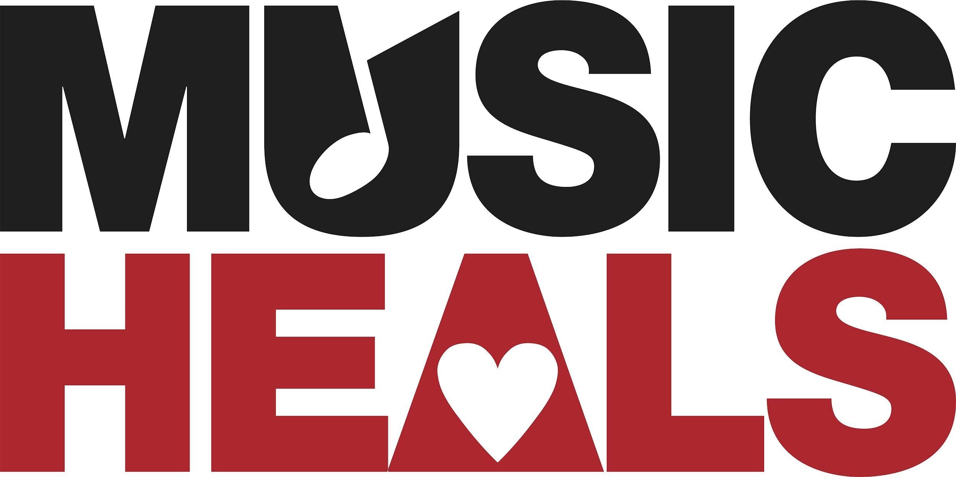 Application Form
This form is a Word Doc. Please save the document to your desktop to save your progress.
Please be sure you have read and understood the eligibility requirements before moving forward with the application:
Eligibility & Requirements
Music Heals’ mandate is to fund existing music therapy programs in nonprofit organizations and facilities led by Certified Music Therapists. We seek to support the sustainability and expansion of these programs. Please note we are unable to direct funds to private MTA practices and/or individuals.

To qualify for funding, programs must:

- Be facilitated by a Certified Music Therapist in Good Standing with the CAMT and their provincial association. Proof of renewal required.
- Be associated with a registered foundation or charity.
- Agree to use 100% of the funding towards the salary of the Music Therapist.

Applications should be written in collaboration between the program manager(s) and music therapist(s).

Please submit your application via email to: cindy@musicheals.ca
Subject: 2022 Music Heals Funding Application - [Program Name]

Application Deadline: Friday, October 7th, 2022
No late applications will be considered. You will be notified of the status of your application by December 1st, 2022.

I. ORGANIZATION CONTACT INFORMATION
1. Name of Facility:
Address:
Website:
Phone:
Name of Program Manager :
Email Address:
Phone:
2. Name of Non-Profit Organization/Charity:
Address:
Website:
Phone:
Charity Contact Name:
Position:
Email Address:
Phone:
3. If funding is approved, the cheque is to be made out to:

II. MUSIC THERAPIST(S) INFORMATION
Please list all the MTA’s onsite who will benefit from this funding:
Music Therapist Name:
Email:
MTA #
Contract or Employee at this site:
No. of hours currently at site: ________ Hourly wage: $______ No. of years at site: _____
Additional Music Therapist Name: (If Applicable) _____________________________________
Email:
MTA #
Contract or Employee at this site:
No. of hours currently at site: ________ Hourly wage: $______ No. of years at site: _____
Additional Music Therapist Name: (If Applicable) _____________________________________
Email:
MTA #
Contract or Employee at this site:
No. of hours currently at site: ________ Hourly wage: $______ No. of years at site: _____

III. ORGANIZATION & PROGRAM INFORMATION
1. Your Organization’s Mission Statement

2. Describe the current music therapy program including types of service and demographic of clients served. Include statistics such as number of clients served, age, and background. (200 words max.):

3. Compared to other programs offered at your facility, how does Music Therapy uniquely address the needs of clients in your program? (200 words max.)

4. Describe the ways in which your organization is committed to sustaining and expanding your music therapy program. (200 words max.)

III. NEEDS ASSESSMENT & BUDGET
1. Start date of the program (If successful, you will receive funding by January 1st, 2023. Funds must be used by December 31st, 2023.)
DD/MM/YYYY

2. How much funding has your facility budgeted for the program in 2023?
(Excluding potential funds from Music Heals)
$________________________
3. How much funding are you requesting from Music Heals (max. $20,000)?
$________________________

4. Would this funding be used to sustain or increase music therapy hours at your facility? (Expand in question 5)
________________________

5. Please describe how this funding will be used (500 words max.) including details such as:
- Total number of hours per week added
- Total weeks per year added
- Expanded reach of clients served
- Hiring an additional Music Therapist
- New programs

IV. ATTACHMENTS & CHECKLIST
Please ensure to prepare and attach the following documents:
- A copy of current MTABC or provincial membership
- A copy of current CAMT membership
- (For Contract MTA’s) A copy of current liability insurance
- A letter of support from the Facility and/or Foundation stating 100% of funds will be used towards the salar(ies) of the Music Therapist
V. ACKNOWLEDGMENT By submitting this application form you acknowledge and agree that you have read and understood the eligibility requirements.
- I Agree

Thank you. We look forward to reviewing your application. If you have any questions please reach out to cindy@musicheals.ca

